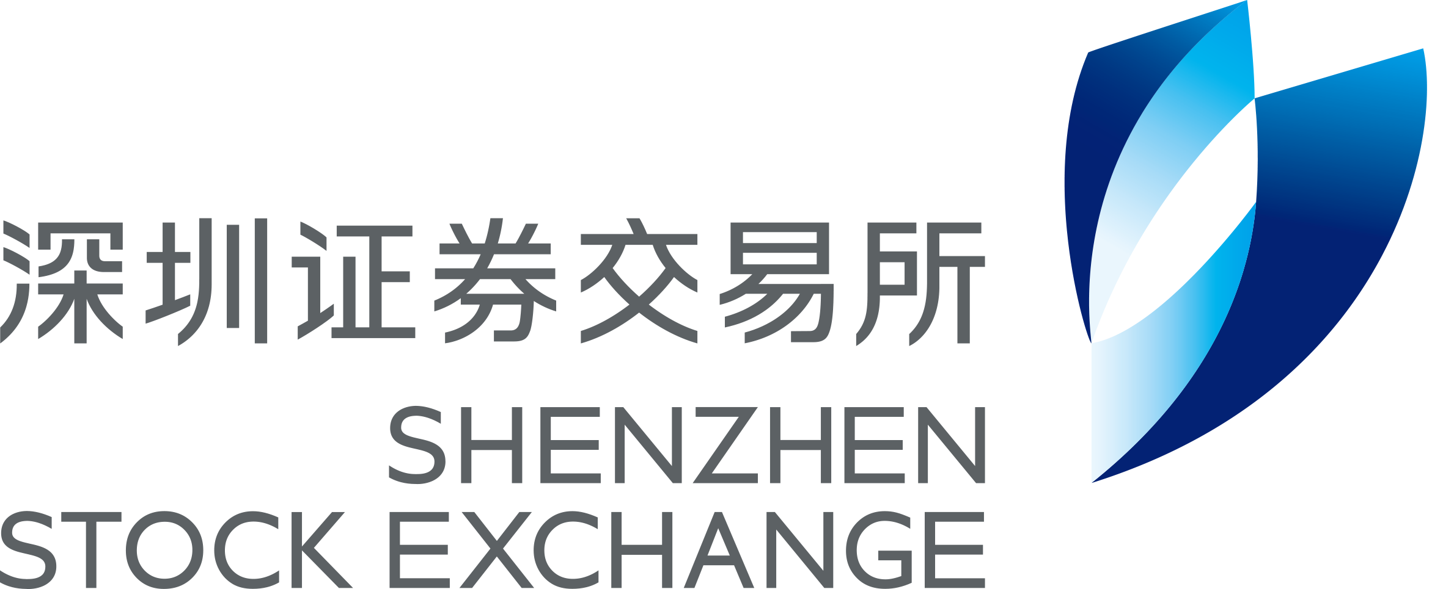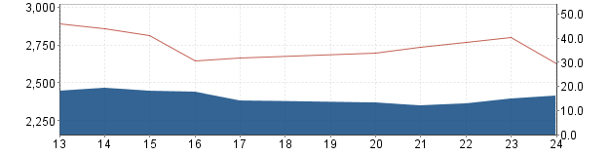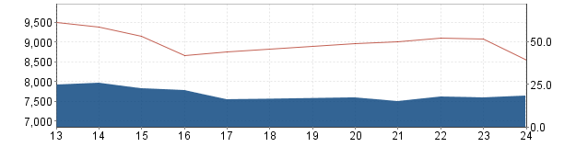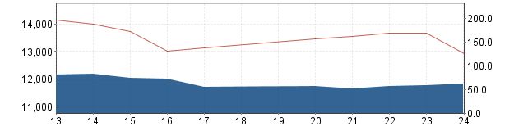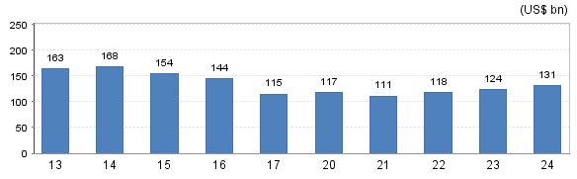
Shenzhen Stock Exchange Market Bulletin
July 27, 2020 (Issue 22)
SZSE Component Index (July 13 – July 24)

Listed Companies (No.) | 2,258
- Main Board | 469
- SME Board | 958
- ChiNext Market | 831
Funds | 547
Bonds | 7,777
Market Cap. (US$ bn) | 4,288.8
- Main Board | 1,248.1
- SME Board | 1,780.2
- ChiNext Market | 1,260.6
Average Turnover Ratio | 2.42
Average P/E Ratio | 30.94
No. of IPO (YTD) | 58

Market Summary
Most Active Companies
Market News
New Listing
Miracll Chemicals (300848)
Miracll Chemicals Co., Ltd. principally engages in research and development, production, sale and technical service of TPU. In 2019, its operating income reached 649 million yuan with the net profit of 83.36 million yuan.
Daily Trading Value (July 13 – July 24)
SME Index (July 13 – July 24)
ChiNext Index (July 13 – July 24)
Index Value Index Trading Value
Trading Value (US$ bn)
Index Value Index Trading Value
Trading Value (US$ bn)
Index Value Index Trading Value
Trading Value (US$ bn)
Top Gainers
Top Decliners
1 | East Money Information Co., Ltd. (300059)
2 | Luxshare Precision Industry Co.,ltd. (002475)
3 | Wuliangye Yibin Co.,ltd. (000858)

1 | Miracll Chemicals Co.,ltd. (300848)
2 | Nanjing Cosmos Chemical Co., Ltd. (300856)
3 | Tianjin Jingwei Huikai Optoelectronic Co.,ltd. (300120)

1 | Anhui Shengyun Environment-protection Group Co., Ltd (300090)
2 | Shenwu Environmental Technology Co.,ltd (300156)
3 | Gettop Accoustic Co.,ltd. (002655)

Title
Comments

- China to connect interbank and exchange bond markets
Recently, the People’s Bank of China (PBoC) and the China Securities Regulatory Commission (CSRC) release a proposal for connectivity of market infrastructures between the interbank bond market and the exchange bond market. The proposal covers three areas of connectivity. First, the electronic trading platforms of the interbank bond market and the exchange market will jointly provide investors with bond trading and other services. Second, the central registration, depository and settlement agencies will jointly provide bond issuance, registration, custody, clearing and settlement services. Third, the PBoC and the CSRC will strengthen regulatory cooperation and coordination. The proposal is intended to enhance the efficiency of China’s bond market now fragmented in types of issuers and investors. Currently, the exchange bond market, regulated by the CSRC is operated by Shenzhen Stock Exchange and Shanghai Stock Exchange with CSDC as the CSD while National Association of Financial Market Institutional Investors, and China Central Depository & Clearing Co., Ltd. serves as the trading platform and CSD for inter-bank bond market, both regulated by the People’s Bank of China.
2. CSRC encourages M&A and share incentive for securities and fund companies
COSMOS (300856)
Nanjing COSMOS Chemical Co., Ltd. principally engages in research and development, production and sale of daily chemical raw materials. In 2019, its operating income reached 1,100 million yuan with the net profit of 153.70 million yuan.

ToLand (300855)
Jiangsu Toland Alloy Co., Ltd. principally engages in research and development, production and sale of high-performance alloys, special stainless steels and other high-performance alloy materials and their products. In 2019, its operating income reached 484 million yuan with the net profit of 101.95 million yuan.

Shenhao Technology (300853)
Hangzhou Shenhao Technology Co., Ltd. principally engages in research and development of smart grid related technology products. In 2019, its operating income reached 405 million yuan with the net profit of 113.06 million yuan.

On July 17, the CSRC issued a circular to encourage securities companies and fund management companies to have M&A and equity-based incentive. The securities and fund industry which is composed of 133 securities companies and 145 fund companies respectively, is expected to have more market-oriented M&A to strengthen the competitiveness of the whole industry. At the same time, securities and fund companies are encouraged to launch employee stock ownership or equity incentive plans, to bind the interests of employees and companies together, enhancing company cohesion and competitiveness.
Since the 1990s, China’s securities industry has witnessed four waves of M&A. Since 2010, the securities industry has set off the fourth wave of market-oriented M&A, including top brokers acquiring small and medium-sized brokerages, such as CITIC’s 13.46 billion acquisition of Guangzhou Securities, the M&A between small and medium-sized brokers, as well as business integration between securities companies controlled by the same entity or individual or have a mutual control relationship. In the meantime, securities firms are actively expanding overseas business through overseas M&A, such as CITIC's acquisition of CLSA.

3. Measures are released by the Supreme Court to strengthen bond investor protection
On July 15, the Supreme People's Court (SPC) officially released the Minutes of National Court Hearing of Bond Dispute Cases which clarify and unify practices of investors’ protection for bond market.
First, It clarified that the decision made by bondholders’ meeting as the decision-making body among bond holders has the binding effect as long as due process has been gone through;
Second, the role of a trustee as the litigation body has been confirmed;
Third, it has been clarified that the court where the issuers of the bond is registered is where the litigation will be conducted;
Fourth, to specify the issuer’s scope of liability in breach of contract, the calculation of the loss of fraudulent issuance and misrepresentation, and the plea of causality. The issuer’s liability for compensation should be determined by the actual losses of the bondholders and bond investors, and the cost of violations in the bond market should be increased in accordance with the law;
Fifth, to specify the responsibility of the trustee, bond underwriter and service provider. The bond underwriters and bond service agencies should strictly implement the verification and inspection responsibilities, and the liability shall be determined in accordance with the degree of fault;
Sixth, to clarify the bankruptcy administrator's responsibility to disclose information continuously and confirm claims so as to ensure that litigation procedures can be carried out in a timely manner, protect the legal rights and interests of bondholders, and effectively resolve risks, straighten out market relationships, reassure parties concerned and maintain market order.

4. Shenzhen Stock Exchange Launched Its IT system for the ChiNext Market Reform and Registration-based System
On July 25, the Shenzhen Stock Exchange, CSDC, and China Securities Finance conducted technical test of supporting systems of ChiNext reform and pilot registration system, including online issuance system. From July 27 on, the new technology system has been up-and-running which fully supports market participants’ needs regarding the online offering, transaction settlement, securities margin trading and the like for the ChiNext stocks and depository receipts under the registration-based IPO system.

- The State Council to further improve the business environment for market entities.

On July 21, the State Council issued a circular to optimize business environment for foreign trade and investment. "Pre-arrival declaration" is put in place to boost customs clearance efficiency for imports and exports, allowing enterprises to make a declaration in advance, thus inspection and release can be completed as soon as goods arrive in a customs surveillance zone.

Analysis

Highlights on Delisting Rules of ChiNext listed Companies according to the Rules Governing the Listing of Shares on the ChiNext Market of Shenzhen Stock Exchange (2020 Revision)

According to the newly-amended Securities Law and the Measures for Continuous Regulation of Listed Companies on the ChiNext Market (Trial), SZSE abolished, revised and formulated relevant business rules for continuous regulation of the ChiNext Market. SZSE revised the Rules Governing the Listing of Shares and the Guidelines for Standard Operation, abolished 14 rules including the Memo of Information Disclosure, released 7 business guides, to establish a simple, efficient rule system with the Rules Governing the Listing of Shares at its core, the Guidelines for Standard Operation and Guidelines for Information Disclosure as its trunk, and business guides as its supplements. In this issue, we summarize the highlights of the delisting rules for ChiNext Market after reform.

There are four sets of standards for compulsory delisting based on trading indicators, financial indicators, compliance indicators and severe violation of rules and laws indicators respectively, upon any of which the compulsory delisting process will be triggered. In the newly amended Listing Rules for ChiNext, there are two major changes which will lead to more value-based investment in the capital market. Firstly, the minimum standards for maintenance of listing status have been raised. Secondly, the process of the delisting is streamlined and the duration is shortened.
Disclaimer: The content is for reference only. Shenzhen Stock Exchange does NOT guarantee its accuracy. Listed companies or data mentioned in this presentation shall NOT be viewed as investment recommendations. SZSE does NOT assume any liability resulting from use of data and references information contained in this bulletin.
We welcome any feedbacks with respect to Market Bulletin or other information services offered by the SZSE. Should you have any inquiries, comments or proposal for cooperation, please let us know at international@szse.cn

Rotating Editor: Yuan Yao
Co-Editors: Xue Dong

A summary on compulsory delisting standards and process (including highlights in the new rule) are provided as follows:

Compulsory Delisting Standards and Process (including highlights in the new rule)
 | ChiNext Delisting standards after reform  (delisting process is triggered upon any of the standards) | What is new in terms of standards | ChiNext Delisting process after reform | What is new in terms of process
Trading -based standards | Market capitalization < 300 million for twenty consecutive trading days | Newly added | - Standards are triggered  - Companies will be labeled *ST  - Termination of listing | The delisting transitional period for trading-related delisting was removed.
Trading -based standards | Trading volume over 120 consecutive trading days < 2 million shares | change from 1 million shares
Trading -based standards | Less than 400 shareholders for twenty consecutive trading days | change from 200 shareholders
Financial -based standards | net profit for the most recent financial year is negative and operating income < RMB 100 million | - Change from loss for 3 financial years in a row  - net profit is defined as whichever of the lower before or after deducting non-recurring gains and losses | - Standards are triggered  - Companies will be labeled *ST  - Companies will be terminated from listing if in the upcoming financial year it continues to meet the standard or the auditor makes qualified opinions | - The delisting duration is shortened by one year as the one-year suspension of listing during which companies may remove *ST label if its financial condition is alleviated is removed.  - qualified opinions by the auditor is added as a condition for termination of listing
Financial -based standards | net profit for the most recent financial year is negative and net asset is negative | - Change from negative asset for most recent year  - net profit is defined as whichever of the lower before or after deducting non-recurring gains and losses
Financial -based standards | Disclaimer opinion or adverse opinion is issued by the auditor for the most recent annual report | Change from two years in a row
Compliance-based standards | Fails to meet any of the following compliance requirement and still fails to do so within two months since trading in the company’s shares is halted for the same reason  - disclose annual or semi-annual report within the specified time limit,  - correct major defects in information disclosure or operational compliance within the specified time limit  - correct major accounting mistakes within the specified time limit | - Change from four month for being unable to correct major accounting mistakes  - “major defects in information disclosure or operational compliance” is newly added | - Standards are triggered  - Companies will be labeled *ST  - Companies will be terminated from listing two month after *ST label if they continue to meet the standards | N.A.
Compliance-based standards | Shareholding distribution doesn’t meet standard | - A. |  | N.A.
Compliance-based standards | Liquidation, restructing and bankruptcy | N.A. |  | N.A.
Standards related to severe violations of rules and laws | Fraudulent listing, severe violation of law on information disclosure or other severe disruption of the market order | N.A. | (1) Standards are triggered  (2) Companies will be labeled *ST  (3) Companies will be terminated from listing when the court has made specific verdict | The suspension time for compulsory delisting was postponed to “the day when company receives the administrative penalty decision from the relevant administrative authority or when the people’s court’ verdict comes into force”
Standards related to severe violations of rules and laws | Severe violations of law in the terms of national security, public security, ecological security, production safety and public health | N.A.

* The decision of termination of listing is made through a hearing of listing committee by SZSE and companies may file objections. Before termination of listing, there is a one-month delisting transitional period during which investor may sell their stocks within a specific price range.
* SZSE adjusted relevant standards on trading-related delisting for red chip enterprises, stating that when the “face value delisting” indicator is applicable, the standard that “the daily closing price is lower than RMB 1 for 20 consecutive trading days” should be adopted. The “number of shareholders” indicator is not applicable when red chip enterprises issue depository receipts.

(Please be notified that the summary is for reference only. SZSE international team makes due efforts in preparing the materials but doesn’t guarantee its completeness and accuracy.
Please check Measures for Continuous Regulation of Listed Companies on the ChiNext Board (Trial) for detailed and accurate rules.)
Add: Shenzhen Stock Exchange, 2012 Shennan Blvd, Shenzhen, PRC 518038 Website: http://www.szse.cn/English/index.html Email: international@szse.cn

Add: Shenzhen Stock Exchange, 2012 Shennan Blvd, Shenzhen, PRC 518038 Website: http://www.szse.cn/English/index.html Email: international@szse.cn

